PROJECT REPORT

Title: Customer Churn Analysis Using Machine Learning

Author: K.B.Srinidhi Data Analyst intern at elevate labs

Date: 7-09-2025

1. Objective

* Predict which customers are likely to churn using historical data.
* Identify key factors influencing customer churn.
* Provide actionable insights to reduce churn and improve retention.

2. Dataset Description

* + Source: Telecom customer data
  + Number of records: (insert dataset size)
  + Features used:
  + Tenure, MonthlyCharges, TotalCharges
  + Call duration, Recharge frequency, Complaints
  + Contract type (Two year / Monthly)
  + Phone Service, Paperless Billing
  + Payment Method, Gender
  + Churn Score

3. Data Pre-processing

* Missing values handled and numeric conversion applied.
* Categorical variables encoded using one-hot encoding:
* Contract, PhoneService, PaperlessBilling, PaymentMethod, Gender
* Feature scaling applied where necessary for numeric data.

4. Model Used

* + Logistic Regression
  + Train-test split: 70:30
  + Hyperparameters: default for Logistic Regression
  + Evaluation metrics:
  + Accuracy
  + ROC Curve
  + AUC

5. Model Evaluation

* + ROC Curve: 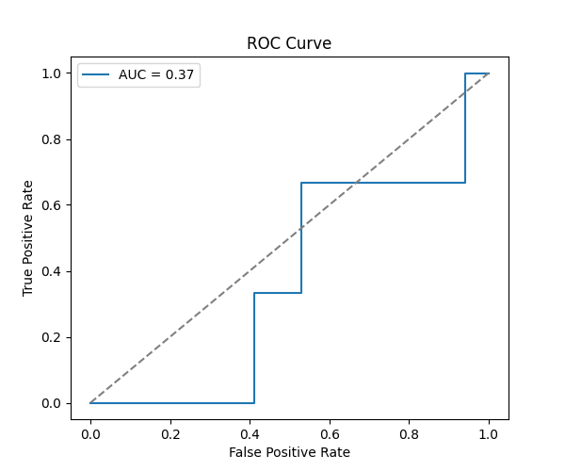
  + Shows model's discrimination ability between churn and non-churn customers.
  + Coefficients Plot: 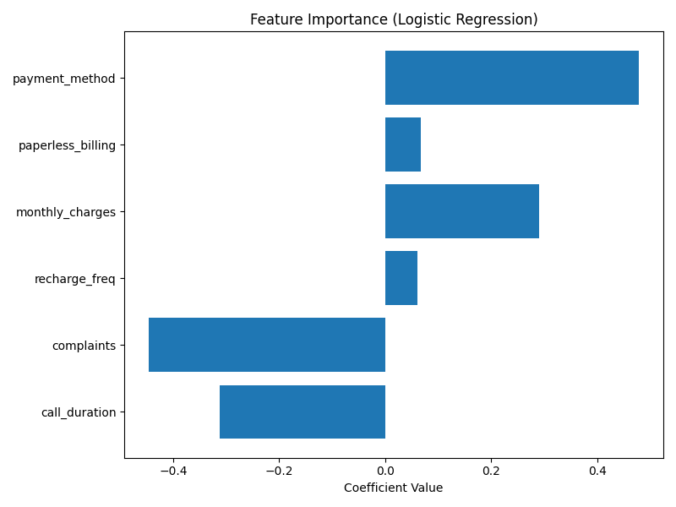
  + Indicates the direction and magnitude of influence of each feature.

6. Feature Importance Analysis (SHAP)

* + SHAP summary plot:

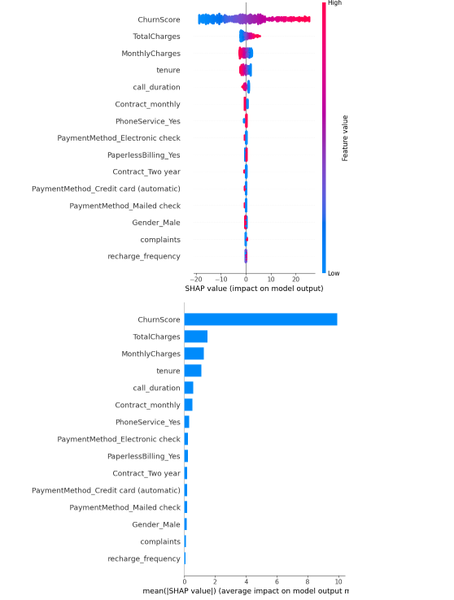

* + Key insights:
  + Contract type and Payment method are top factors influencing churn.
  + High complaints, high monthly charges, and short tenure contribute significantly.
  + SHAP values help explain model predictions at a feature level.

7. Observations & Recommendations

* + Customers with monthly contracts and high complaints have higher churn risk.
  + Consider targeted retention strategies for high-risk segments.
  + Improve customer support to reduce complaints.
  + Offer incentives or loyalty programs for long-tenure customers.

8. Conclusion

* + Logistic Regression effectively predicts churn with good interpretability.
  + SHAP analysis provides transparent feature contribution insights.
  + Recommended actions can help telecom reduce churn and enhance customer satisfaction.